**Problem 1**

**(i)**

> pbinom(8, 30, .35)

[1] 0.2246957

> pbinom(8, 60, .35)

[1] 0.000146853

> pbinom(8, 90, .35)

[1] 9.635798e-09

> pbinom(8, 120, .35)

[1] 2.41666e-13

**(ii)**

> pnorm(8.05, 30*.35, sqrt(30*.35*(1-.35)))

[1] 0.1741711

> pnorm(8.05, 60*.35, sqrt(60*.35*(1-.35)))

[1] 0.0002281969

> pnorm(8.05, 90*.35, sqrt(90*.35*(1-.35)))

[1] 1.095247e-07

> pnorm(8.05, 120*.35, sqrt(120*.35*(1-.35)))

[1] 4.078348e-11

**(iii)**

> abs(pbinom(8, 30, .35) - pnorm(8.05, 30*.35, sqrt(30*.35*(1-.35))))

[1] 0.05052456

> abs(pbinom(8, 60, .35) - pnorm(8.05, 60*.35, sqrt(60*.35*(1-.35))))

[1] 8.134398e-05

> abs(pbinom(8, 90, .35) - pnorm(8.05, 90*.35, sqrt(90*.35*(1-.35))))

[1] 9.988888e-08

> abs(pbinom(8, 120, .35) - pnorm(8.05, 120*.35,

sqrt(120*.35*(1-.35))))

[1] 4.054182e-11

**(iv)**

> n <- c(30, 60, 90, 120)

> abs_errors <- c(abs(pbinom(8, 30, .35) - pnorm(8.05, 30*.35, sqrt(30*.35*(1-.35)))),

+ abs(pbinom(8, 60, .35) - pnorm(8.05, 60*.35, sqrt(60*.35*(1-.35)))),

+ abs(pbinom(8, 90, .35) - pnorm(8.05, 90*.35, sqrt(90*.35*(1-.35)))),

+ abs(pbinom(8, 120, .35) - pnorm(8.05, 120*.35, sqrt(120*.35*(1-.35)))))

>

> plot(n, abs_errors, col="red", xlab="# of Trials", ylab = "Error", main = "Errors of Approximations")

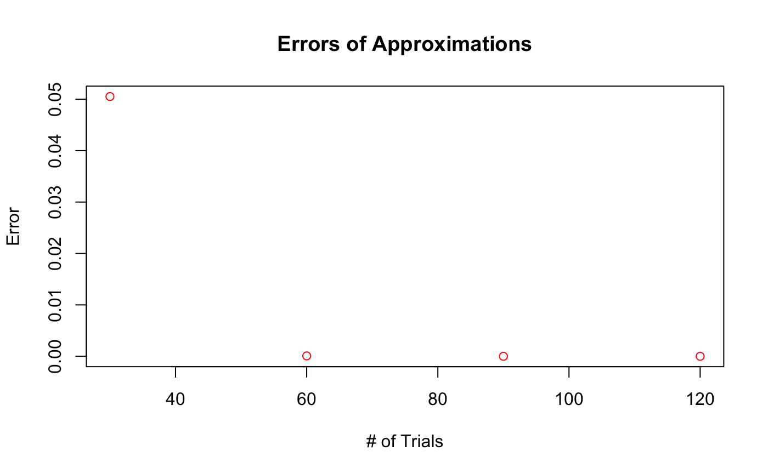

After 30 trials the errors tend to basically zero, so the more trials the less errors.

**Problem 2**

**(i, ii, iii, iv)**  
```{r}

generate_plots <- function(n) {

X_values <- c()

S_values <- c()

for (i in 1:100) {

x <- rnorm(n, mean=2, sd=3)

X_bar <- mean(x)

s_squared <- var(x)

X_values <- c(X_values, (X_bar - 2) / sqrt(9/n))

S_values <- c(S_values, ((n-1) * s_squared) / 9)

}

plot(density(X_values), main=paste("Density curve of (X_bar - 2) / sqrt(9/n) where n =", n))

plot(density(S_values), main=paste("Density curve of (n-1)S^2 / 9 where n =", n))

plot(X_values, S_values, main=paste("Scatterplot for both equations where n =", n), xlab = "(X_bar - 2) / sqrt(9/n)", ylab="(n-1)S^2 / 9")

}

for (n in c(25, 50, 75, 100)) {

generate_plots(n)

}

```

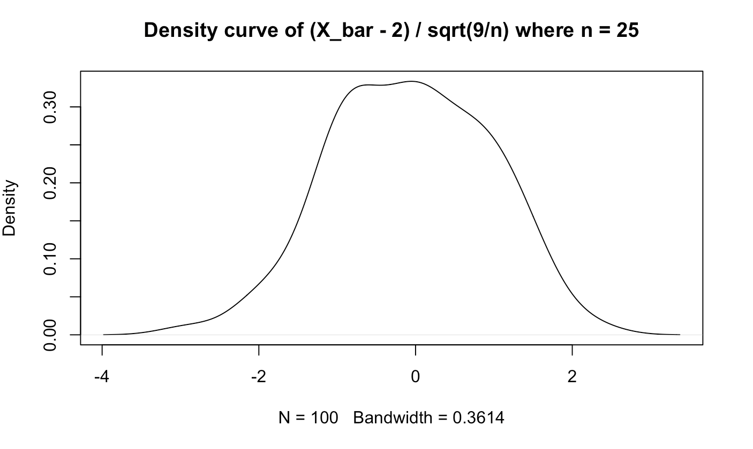

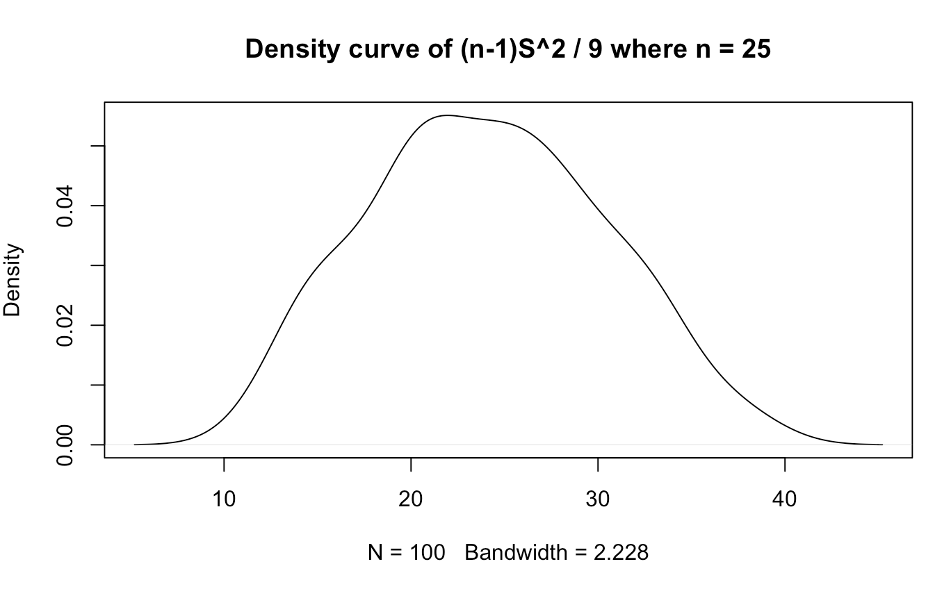

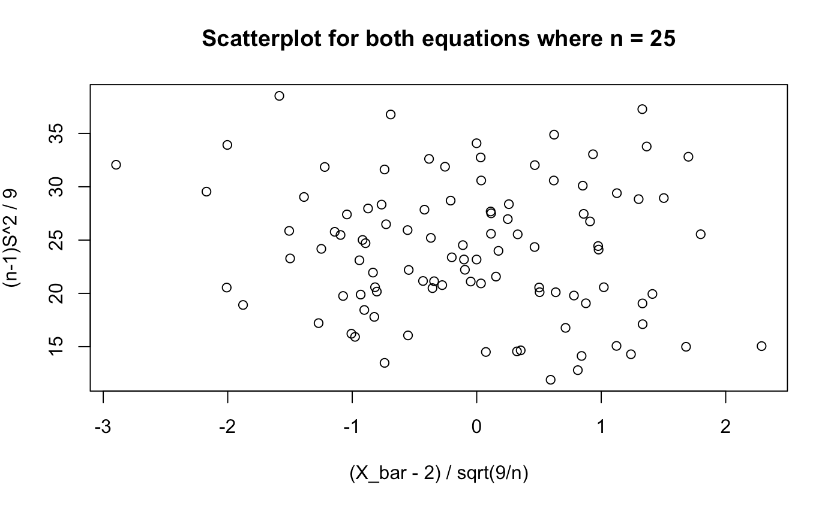

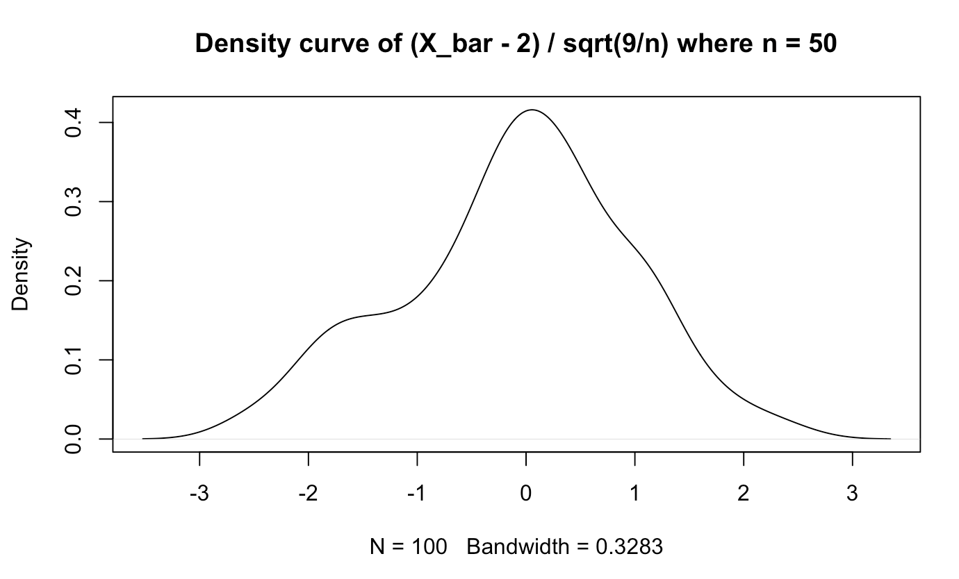

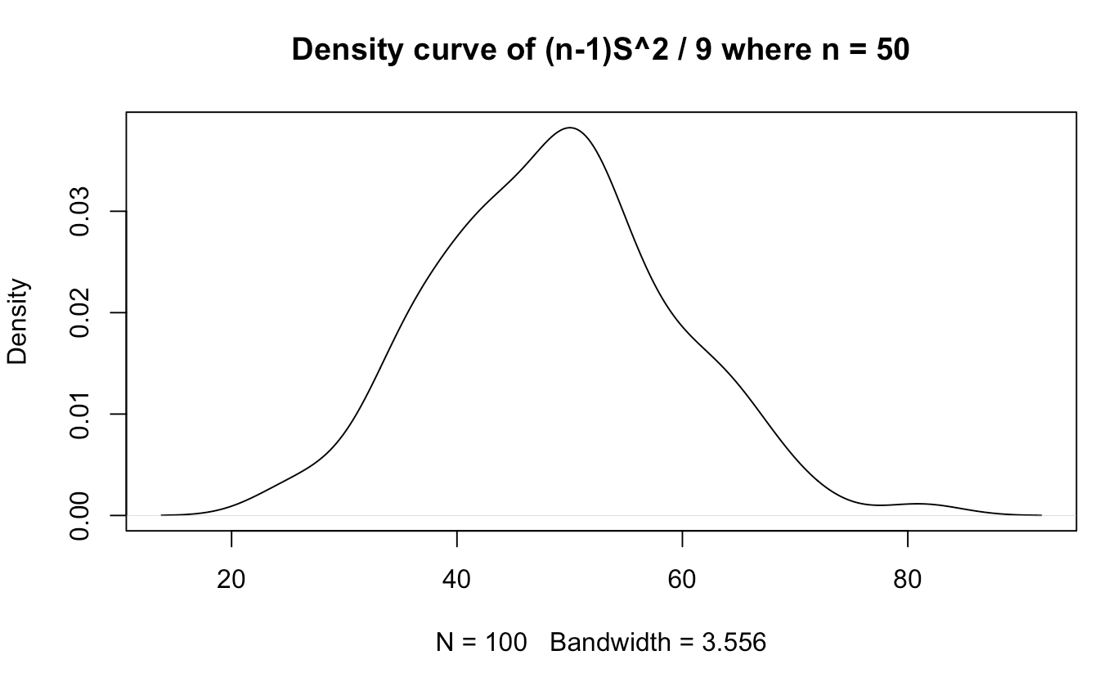

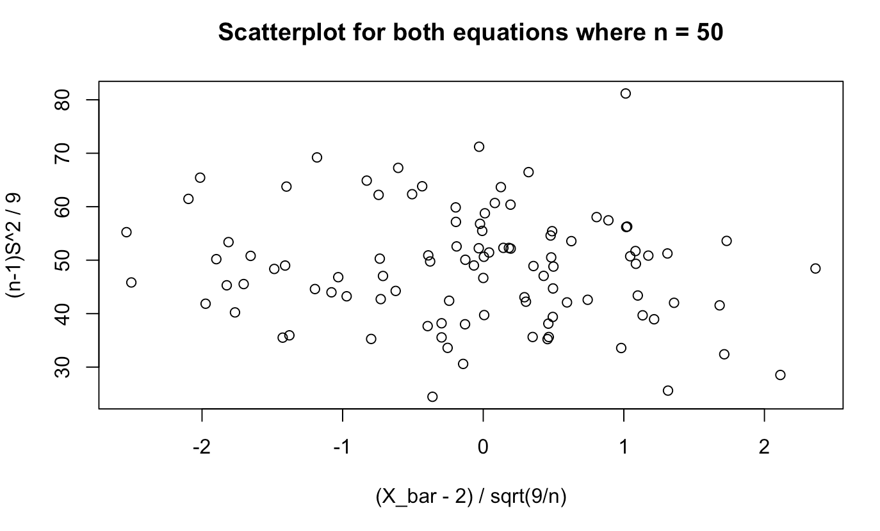

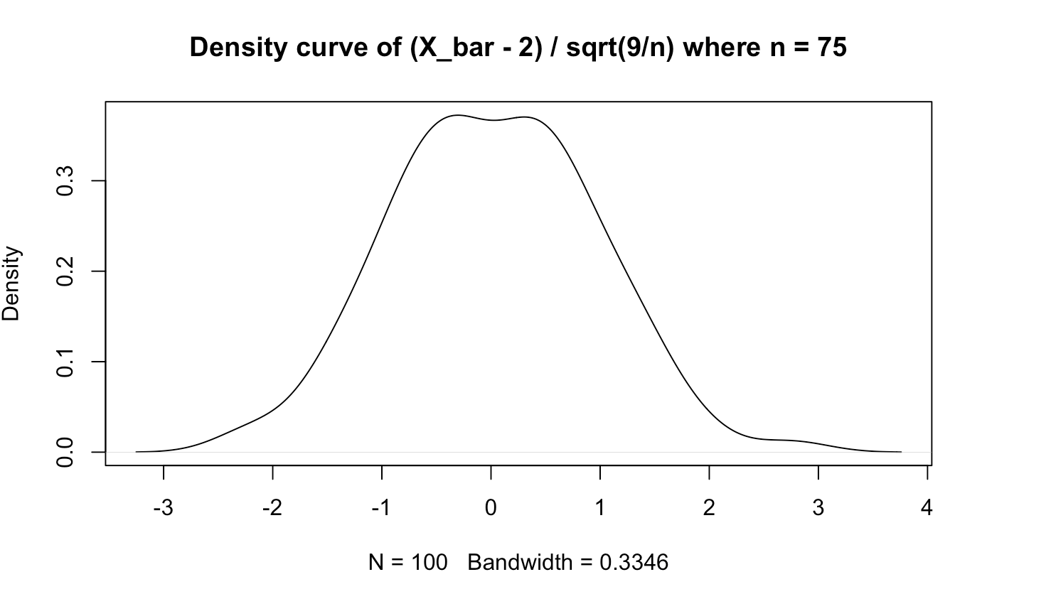

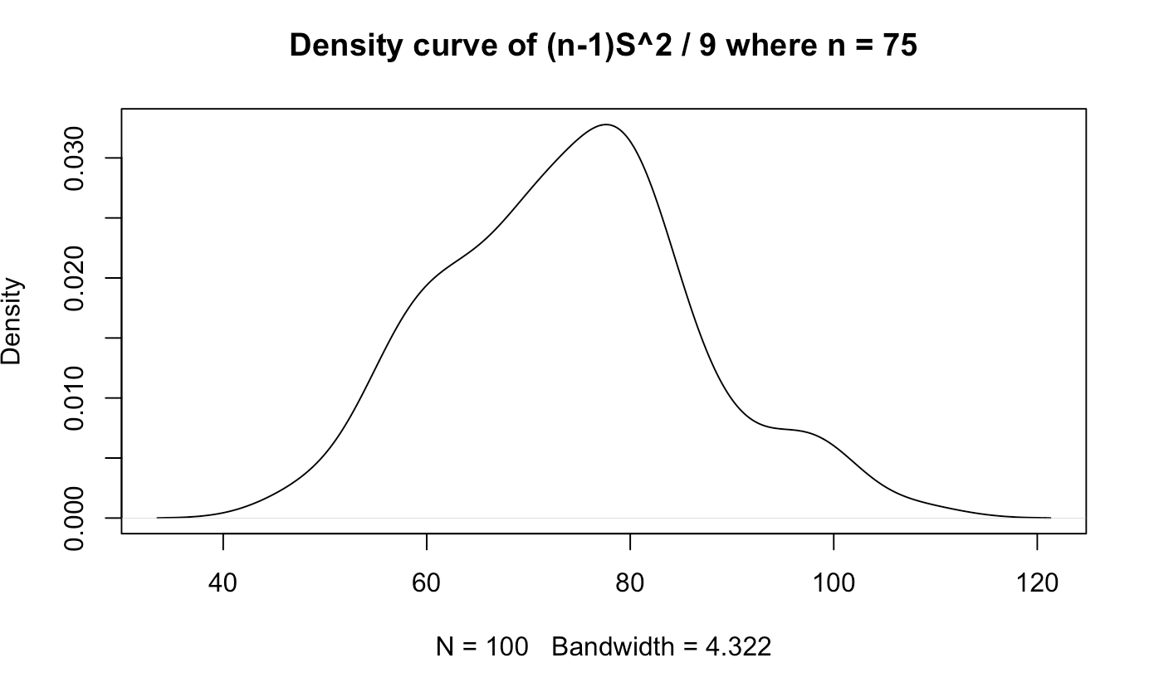

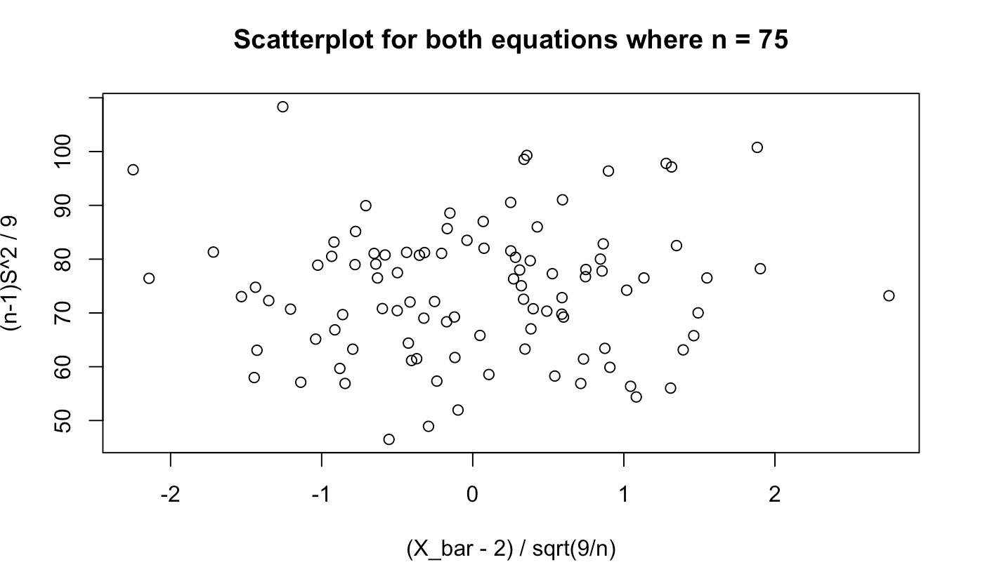

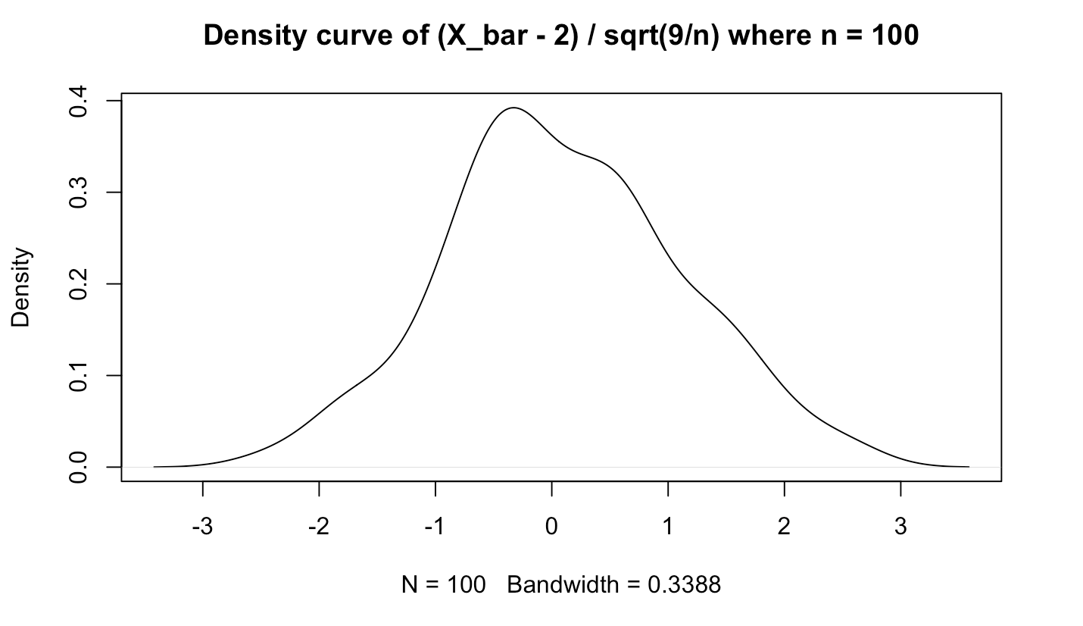

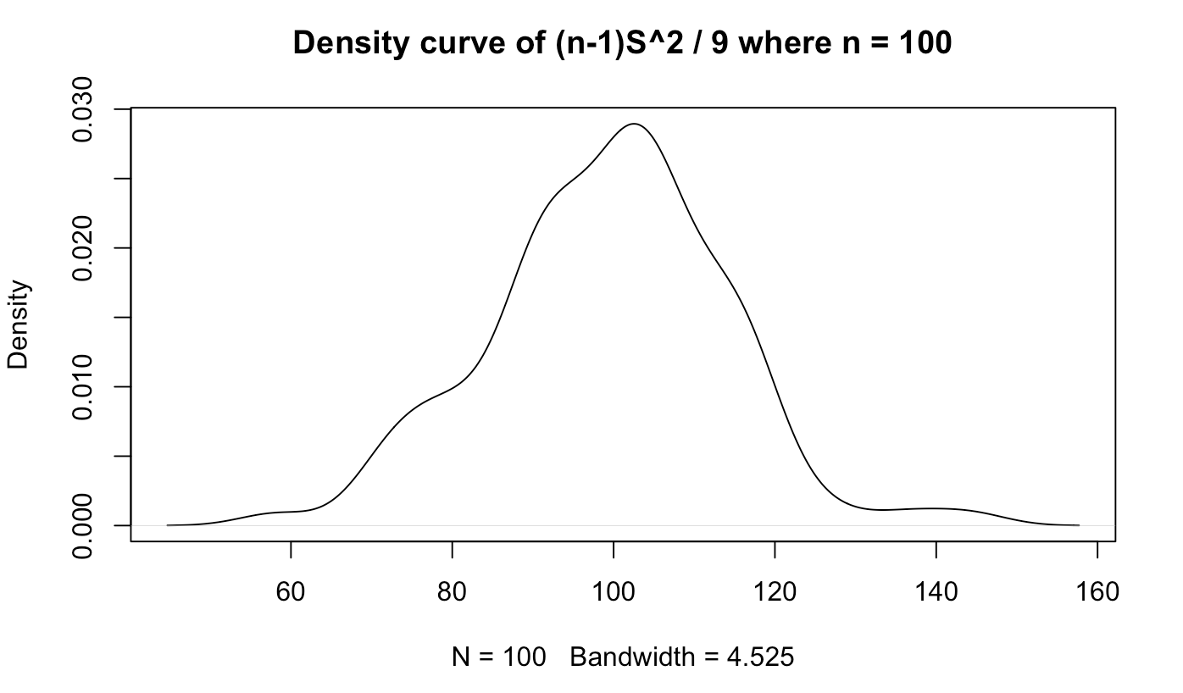

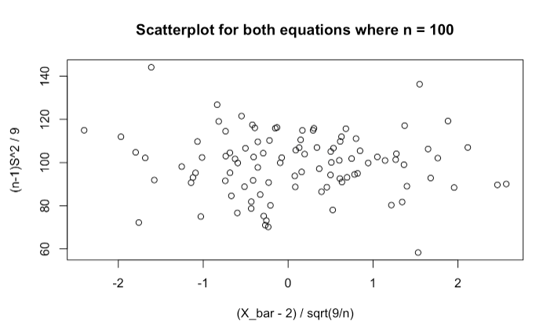

**(v)**

The higher the n, the closer the distribution of (x_bar - 2) / sqrt(9 / n) was to normal while conversely, the distribution for the other equation became less normal.

**(vi)**

As the scatterplots reveal no certain correlation, we can assume the values are independent.

**Problem 3**

**(i)**

> X <- c(-0.4, 0.15, 0.5, -1.2, -0.5, 0.9, 1.5, -0.7, 1.5, -1, 2.25, 3.5, -1.45, 0.2, 2.75)

> n = length(X)

> Xbar = mean(X)

> a1 <- sum((X - 1)^2) / 2

> p1 <- 1 - pchisq(a1, df=n)

> a1 = 17.47

> P(> a2) = 0.2915524

a1 = 17.47 P(Chi-squared > a1) = 0.2915524

**(ii)**

> a2 <- sum((X - Xbar)^2) / 2

> p2 <- 1 - pchisq(a2, df=n-1)

> a2 = 15.83667

> P(> a2) = 0.3234504

a2 = 15.83667 P(Chi-squared > a2) = 0.3234504

**(iii)**

> a3 <- (Xbar - 1) / sqrt(var(X) / n)

> p3 <- 2 * (1 - pt(abs(a3), df=n-1))

> a3 = -1.201627

> P(> |a3|) = 0.2494416

a3 = -1.201627 P(|T| > |a3|) = 0.2494416

**Problem 4**

**(i)**

P(X ∈ (−1, 2)):

> pnorm(2, mean = -1, sd = 4) - pnorm(-1, mean = -1, sd = 4)

[1] 0.2733726

P(Y ∈ (−1, 2)):

> pchisq(2, 10) - pchisq(-1, 10)

[1] 0.003659847

P(T ∈ (−1, 2)):

> pt(2, 11) - pt(-1, 11)

[1] 0.7951977

P(F ∈ (−1, 2)):

> pf(2, 8, 11) - pf(-1, 8, 11)

[1] 0.8578956

**(ii)**

> qs <- c(0.05/2, 0.05, 1 - 0.05, 1 - 0.05/2)

> qs

[1] 0.025 0.050 0.950 0.975

> qnorm(qs, mean = -1, sd = 4)

[1] -8.839856 -7.579415 5.579415 6.839856

> qchisq(qs, 10)

[1] 3.246973 3.940299 18.307038 20.483177

> qt(qs, 11)

[1] -2.200985 -1.795885 1.795885 2.200985

> qf(qs, 8, 11)

[1] 0.2356594 0.3018457 2.9479903 3.6638190

**Problem 5**

**(i)**

The expected value for a binomial distribution would be the product of each trial's possibilities of succeeding. This would look like $Σ_{i=0}^{n}(x_{i}p_{i})=np$. Therefore $E[N ∼ B(n, p)]=np$.

Generally, $Var[N] =E[N^{2}]-E[N]^{2}$. For the binomial distribution, $Var[X] = np+n(n−1)p^{2}-(np)^{2}=np-np^{2}=np(1-p)$.

**(ii)**

According to Slide 20 in slide deck 2, if $X\sim N(μ,σ^{2})$ then $\frac{X-μ}{σ}\sim N(0,1)$. Multiplying standard normal distributions changes the standard deviation but not the expected value, which means that $E[{(\frac{X-μ}{σ})}^{3}]=E[\frac{X-μ}{σ}]=0$.

**(iii)**

The student T distribution is defined as $T=\frac{X}{\sqrt{Y/n}}$ where $X\sim N(0,1)$ and $X\sim {{χ_{n}}^{2}}_{ }$ are independent. $Y/n\sim χ_{1}^{2}$ where $E[Y/n]=1$. Therefore $E[\frac{X}{\sqrt{Y/n}}]=0$.

The student T distribution is symmetric about the y-axis, so $P(T≤t)= 1-P(T≥t)$. We know $F^{-1}(α)=$ some $x$ such that $P(T≤x)=α$. Therefore $-F^{-1}(α)=F^{-1}(1-α)$.

**Problem 6**

**(i)**

$X+Y \sim N(0,13)$;

$μ=-1+1=0$

$σ^{2}=9+4= 13$

$X-Y \sim N(-2, 13)$;

$μ= -1-1= -2$

$σ^{2}=9+4=13$

$W-3X+2Y \sim N(7, 113)$;

$μ=2-3(-1)+2(1)=7$

$σ^{2}=16+(-{3)}^{2}(9)+2^{2}(4)= 113$

**(ii)**

Recall W, X, and Y follow normal distributions and are mutually independent.

$\frac{(X+1)^{2}}{9}={(\frac{X+1}{3})}^{2}\sim χ_{1}^{2}$

$\frac{(Y-1)^{2}}{4}={(\frac{Y-1}{2})}^{2}\sim χ_{1}^{2}$

$⇒\frac{(X+1)^{2}}{9}+\frac{(Y-1)^{2}}{4}={2χ}_{1}^{2} \sim χ_{2}^{2}$

$\frac{(W-2)^{2}}{16}={(\frac{W-1}{16})}^{2}\sim χ_{1}^{2}$

We already know $\frac{(X+1)^{2}}{9}+\frac{(Y-1)^{2}}{4} \sim χ_{2}^{2}$

$⇒\frac{(W-2)^{2}}{16}+\frac{(X+1)^{2}}{9}+\frac{(Y-1)^{2}}{4}\sim χ_{3}^{2}$

**(iii)**

Recall W, X, and Y follow normal distributions and are mutually independent.

$\frac{Y-1}{2}\sim N(0,1)$

$\frac{(X+1)^{2}}{9}+\frac{(W-2)^{2}}{16}\sim χ_{2}^{2}$

$\frac{\frac{Y-1}{2}}{\sqrt{[\frac{(X+1)^{2}}{9}+\frac{(W-2)^{2}}{16}]/2}}\sim T_{2}$ because it is of the form $\frac{N(0,1)}{\sqrt{χ_{n}^{2}/n}}$.

$\frac{X+1}{3}\sim N(0,1)$

$\frac{(Y-1)^{2}}{4}+\frac{(W-2)^{2}}{16}\sim χ_{2}^{2}$

$\frac{\frac{X+1}{3}}{\sqrt{[\frac{(Y-1)^{2}}{4}+\frac{(W-2)^{2}}{16}]/2}}\sim T_{2}$ because it is of the form $\frac{N(0,1)}{\sqrt{χ_{n}^{2}/n}}$.

**(iv)**

$\frac{(Y-1)^{2}}{4}\sim χ_{1}^{2}≡\frac{χ_{1}^{2}}{1}$

$\frac{1}{2}[\frac{(X+1)^{2}}{9}+\frac{(W-2)^{2}}{16}]\sim \frac{χ_{2}^{2}}{2}$

$\frac{(Y-1)^{2}}{4}/\frac{1}{2}[\frac{(X+1)^{2}}{9}+\frac{(W-2)^{2}}{16}]\sim F_{1,2}$ because it is of the form $\frac{χ_{n}^{2}/n}{χ_{m}^{2}/m}$.

$\frac{1}{2}[\frac{(X+1)^{2}}{9}+\frac{(W-2)^{2}}{16}]/\frac{(Y-1)^{2}}{4}\sim F_{2,1}$ because it is of the form $\frac{χ_{n}^{2}/n}{χ_{m}^{2}/m}$.